Manuscript of Cromwell

Those true of heart and stolid of faith, follow the Path of God to discover the Ring of Solomon’s true power.

Each challenge a number doth give, save the last. The first three doth unlock the chain - in order downwards. The second three doth unlock the box in order down. The final doth give the true location of the Ring’s containment.

- The Language of God

Only the learned man shall proceed.

ארבעה

- The Light of God

Only the enlightened man shall proceed.

Twelve candles doth stand burning alight in a feasting hall,
A strong breeze blows in through an open windowed wall,
And extinguishes three candles that doth burn no more,
You check again soon and see what you saw:
Another candle out from the ill-tempered breeze,
You shut closed the window with the greatest of ease,
Assume now that the wind, no more flames from the candles doth theft,
In the end, how many candles dost thou have left?

- The Fortitude of God

Only the clever man shall proceed.

The first number of the answer is what you seek:

As I|was going to St Ives
I met a man with seven wives
Every wife had seven sacks
Every sack had seven cats
Every cat had seven kits
Kits, cats, sacks, wives.
How many were going to St Ives?

- The Symbology of God

Only the observant man shall pass.

Throughout Luton these symbols be,
The missing symbol holds the key,
The number of the month for which it is main,
Will provide release from mortal pain.

5. The Lessons of God

Only the dedicated man may pass.
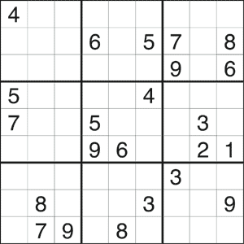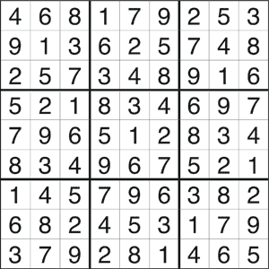

- The Word of God

Only the man of true faith shall proceed.

- The Path of God

The path be open to only those that follow the Cross,
One for the father, one for the son and one for the Holy Ghost,
The box of containment is covered by Cloth,
May discovery herald a new era to which I toast

